Application template for the Online IFIP TC3 Doctorial Consortium: IFIP-TC3-DC’2023
Please complete and send this document to javier.osorio@ulpgc.es before March 31st, 2023

PhD Student contact details

First name:
Last name:
Centre:
Institution:
Country:
Email address:

Time Zone: GMT +/-
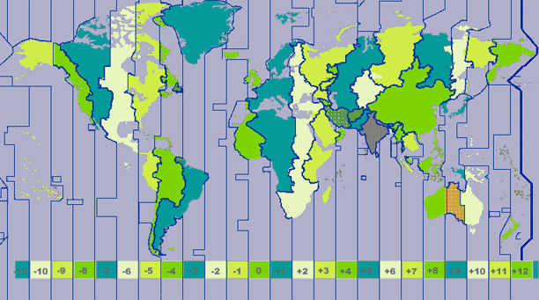

Email address of your PhD supervisor:

Subject

Discipline:

PhD study/manuscript title

Educational sector level
For Didactics or Learning Science, please specify the target educational sector level if it applies:
Primary, Lower Secondary, Upper Secondary, Higher Education

Keywords (max 5):

Research Question(s):

Research plan (200 words maximum)
This section will help supervisors to prepare feedback on your research design, methodology and methods.

Stage of the work
Phases completed:
Still in progress:
Not started:

Methodology and method(s)

Context (2 lines)

Type of data collected:
e.g.: Documents, interview, questionnaire, digital logs…

Analysis
e.g.: Quantitative or Qualitative or Mixed Methods

Methodological questions
Use this section to ask advisors for some feedback on your research plan, research methodology, and research methods (data collection, data analysis)

Contribution
e.g.: What makes the research I do especially appealing for me? for the discipline? for practice? How can I justify that my research results will match the goals of the dissertation? contribute to advancing the field?
Abstract
In this section, please develop your subject, your research questions and methods and the kind of results you’re seeking. (half to one page maximum).

Bibliography (optional)
Up to 5 key references useful for your work.

Discipline: Computer Science, Learning Science, Educational Technology, Computer Education...

